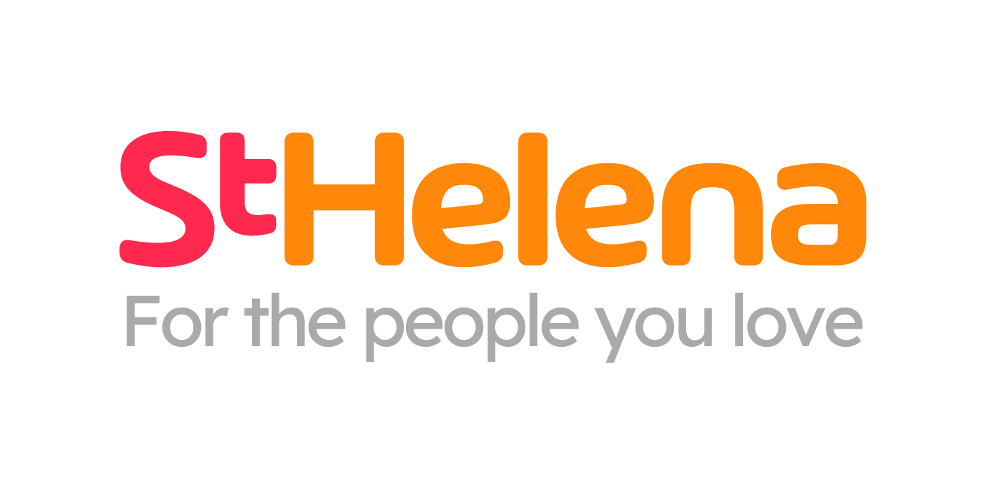

Helping local people face incurable illness and bereavement, supporting them, their families, friends and carers.

Recruitment pack
Healthcare Assistant
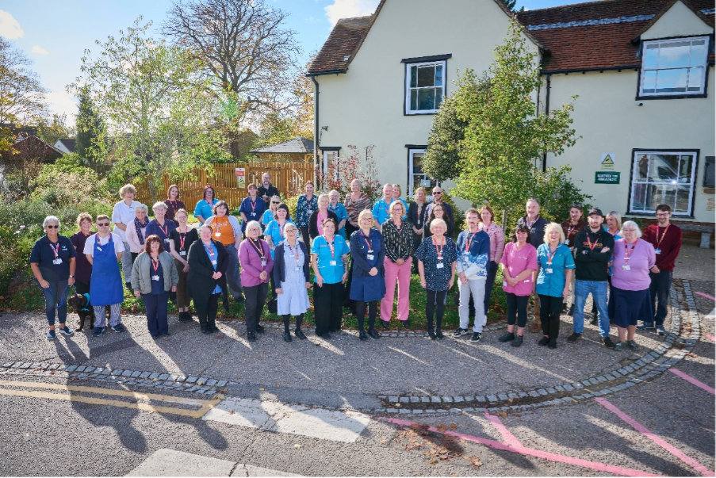

Who is St Helena?

Here at St Helena, we believe that everyone living with an incurable illness has the right to live and die with choice, compassion and dignity. Families deserve to be cared for and anyone coping with loss should be supported through their grief.

Our vision is to create a community where everyone knows that as the end of their story draws near, they will be cared for and die where they choose to be; where loved ones have the opportunity to make the most of life together, surrounded by people who care and support one another.

Since we opened in 1985, this belief drives us to provide the best end of life care and bereavement support to everyone in north east Essex, not just today but for years to come.

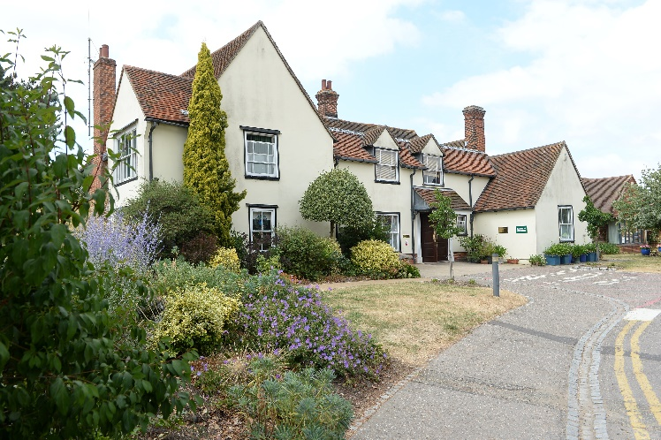

Every year we support more than 4,100 local people facing dying, death and bereavement.
By focusing on their physical, emotional and spiritual needs, we aim to bring comfort and relief to all those who need it, offering the people of north east Essex individual care and total support, regardless of their diagnosis or personal circumstances.
By visiting them in their homes, over the phone with our 24/7 advice line, and at the Hospice in Colchester, through all the smiles and all the tears we guide those who need us, because we believe in making every memory matter.
Not only do we support local people in our community facing incurable illness, but we also support adults and children living in north east Essex through bereavement, regardless of how or where their loved one died.
St Helena is an independent charity, providing our services free of charge. The equivalent of 7 out of 10 of the patients and families we care for and support are funded by people in our local community giving donations, buying from our shops, playing our lottery and leaving gifts in Wills.
We rely on the help and generosity of our fundraisers, donors and volunteers to continue to provide our services. Without them we wouldn’t be here.
What does the role entail?

Place of work | St Helena Hospice In Patient unit IPU
Salary | £12.71 per hour
Contract type | Bank
Reports to | Samina Haig-Earle/Emma Kent
Manages | na
Budget responsibility | na
Travel | na

- Take your career to the next level working with amazing like-minded people
- Work for a company who gives you a platform to do amazing things
- Be in a job where you really make a difference

What are we looking for?
Enthusiasm
Passionate about providing excellent care
Reliable
Caring

Job Description

JOB OVERVIEW
JOB TITLE | Healthcare Assistant
DEPARTMENT | Hospice MDT
LOCATION | Colchester
REPORTS TO | Senior Sister

KEY WORKING RELATIONSHIPS
All staff and volunteers at St Helena  Patients, families & carers | Counterparts in other healthcare settings  External agencies
KEY PRIORITIES
- To assist Registered Nurses, Occupational Therapists and Physiotherapists in providing high standards of specialist palliative care to patients and their relatives.
- Identify and adapt clinical support given under the varying professions guiding principles of care and be able to switch approach as directed.
- The care will be planned and assessed by the Registered Nurses and Therapists and provided under the direct supervision of the registered nurses or other members of the multidisciplinary team.
DUTIES & RESPONSIBILITIES
- In conjunction with other members of the team, and in line with your level of competency, assist in meeting the needs of patients: hygiene, elimination, nutritional, mobilising, maintaining independence, pain.
- Be able to recognize and advocate the promotion of independence and personalized care based on patients’ life histories and expressed preferences about their own care.
- Meet the therapy needs of the patient through the delivery of the therapy plan of care devised by the registered therapist.
- Identify the psychosocial and spiritual needs of families and friends under his/her care and communicate this to the supervisor.
- To implement rehabilitation programmes devised by the OT or physio and when needed, follow up interventions in the community.
- To practice daily living activities with patients on the ward under the guidance of the OT/Physio, e.g. functional transfers, personal care or mobility.
- To assess and provide basic mobility and daily living equipment aids to patients, reporting to the OT or PT as appropriate and arrange for loan or replacement of equipment with statutory services.
- To implement therapeutic interventions such as exercise, stretching, energy conservation, pacing and relaxation, reporting to OT/PT as necessary.
- Perform Last Offices to deceased patients including safe custody of valuables and belongings.
- Maintaining health & safety within the ward area i.e. ensure fire exits are clear, cupboards safely stocked & hazards removed and reported.
- Work alongside volunteers and ward staff within the unit and report any concerns about practice to immediate supervisor.
- Ensure that all procedures are carried out are in accordance with agreed standards of care.
- Ensure Infection Control Policies and Procedures are strictly adhered to
- Check and ensure that equipment is clean and in working order ready for use
- Ensure that all information recorded by the individual is in accordance with St Helena policy (i.e patient records, incident/accident reports).
- Escort patients to hospital appointments, home visits or recreational trips.
- Assist in checking Controlled Drugs with Registered Nurse (on completion of Drugs Competency Framework).
- Mentor and supervise new ward based volunteers.
- Ensure you follow all policies and procedures in relation to prevention and infection control
- Undertake and record clinical observations reporting results to Registered Nurse
- Undertake simple dressings independently, within level of competence and assist Registered Nurses with complex dressings.

Education:
- Attend mandatory training as required by St Helena: people moving people, CPR, fire, vulnerable adult & child protection.
- Complete Clinical Support Worker competencies within 12 months of joining St. Helena.
- Willingness to continue to update and develop practice.

GENERAL - Applicable to all roles at St Helena
All of the above activities are governed by the operational policies, Standing Financial Instructions, policies and procedures and standards of St Helena as well as legislation and professional standards and guidelines.
All employees must comply with St Helena’s Equal Opportunity Policy and must not discriminate on the grounds of sex, colour, race, ethnic, or national origins, marital status, age, disability, sexual orientation or religious belief.
Employees have a responsibility to themselves and others in relation to managing risk, health and safety and will be required to work within the policies and procedures laid down by St Helena. All staff have a responsibility to access occupational health, other staff support services and/or any relevant others in times of need and advice.
All employees have the right to work in an environment which is safe and to be protected from all forms of abuse, violence, harassment and undue stress. All employees are responsible for helping to ensure that individuals do not suffer harassment or bullying in any form. All employees will be personally accountable for their actions and behaviour in cases of complaint of harassment or bullying.
St Helena is a smoke free organisation. Smoking is not allowed in any St Helena premises. If you would like help to give up smoking you should contact your GP or call the NHS Stop Smoking Help Line.
St Helena is a charity and all staff are responsible to ensure that funds are spent in the most sustainable and efficient way. Staff may also be encouraged to join fundraising and other business-related activities to promote the charity’s financial well-being.
PERSONAL DEVELOPMENT
Be aware of own development needs and take appropriate action. Keep updated of evidence based practice and government policies related to care. Act as an effective role model at all times.
PROFESSIONAL DUTIES
To maintain personal professional status, ensuring that the requirements laid down by the relevant professional body for registration are compliant.
Exercise professional accountability as guided by the relevant professional body and maintained in accordance with the policies of the department and St Helena.
ANNUAL APPRAISAL
The post holder will be appraised on an annual basis and the process will include a review of the past year’s performance, setting of aims and objectives for the coming year and identification of educational needs.
TRAINING
All staff will undertake such training as is necessary to perform the duties allocated and any mandatory requirements of St Helena. This will include mandatory training in line with your job role.
QUALITY
St Helena aims towards maintaining the goodwill and confidence of its own staff and of the general public. To assist in achieving the objective it is essential that at all times, employees carry out their duties in a courteous and sympathetic manner.
CONFIDENTIALITY
Your attention is drawn to the confidential nature of information collected and used throughout the NHS. The unauthorised use or disclosure of patient, staff or other personal information is a dismissible offence. The unauthorised disclosure of information could also result in a prosecution for an offence, or action for civil damaged, under GDPR.
SAFEGUARDING CHILDREN AND VUNERABLE ADULTS
All St Helena employees are required to act in such a way that at all times safeguards (and promotes) the health and well-being of children and vulnerable adults. Familiarisation with and adherence to St Helena safeguarding policies is an essential requirement of all employees as is participation in related mandatory/statutory training.
VALUES AND BEHAVIOURS
St Helena’s core values and behaviours will be embedded in our recruitment, training and development review and decision making process.
Bold | In an ever-changing world, we have the confidence and determination needed to innovate, stand out from the crowd and make a real difference every day.
Passionate | We love what we do and we are committed to our cause because it means everything to the people in our community who need our help.
Caring | People will always come first at St Helena. Everyone  is welcome and everyone will be looked after as though they are a part of our extended family.
This job description is not an exhaustive document but is a reflection of the current position. Details and emphasis may change in line with service needs and after consultation with the post holder.

PERSON SPECIFICATION

ATTIRIBUTE | ESSENTIAL | DESIRABLE
Qualifications | GCSE level C in English & Maths  Full UK driving licence with access to your own vehicle. | NVQ any level in Care  Computer literacy  St. Helena Drugs Competency Framework
Experience | Experience working with people and handling difficult situations. | Experience of working in health or social care setting.
Skills & Knowledge | Proven awareness of the possible needs of patients, families under the care of St Helena  Knowledge of illness as a carer and the ability to recognise when a person has physical, social, psychological or spiritual care needs.  Driving Licence and car driver  Demonstrated commitment and understanding to the Hospice philosophy and the work of St.  Helena.
Communication | Proven written and verbal communication skills. Clear verbal communication skills demonstrable with a range of people.  Ability to accurately record any information required i.e. patient records, telephone messages or information as requested by  patients | Communication Skills Training
Qualities | Proven ability to work off own initiative and as part of a team.  Flexible to meet needs of service.  Physically able to undertake the job.  Proven coping strategies when under emotional pressure

What is the team like?

Line Manager Samina Haig-Earle
Hello I’m Samina, I am the Senior Sister on the in-patient unit at the hospice. My role is to provide clinical management of the in-patient unit and I line manage the clinical team.
We have 8 beds currently open on the in-patient unit and we admit patients for symptom control and end of life care.
Providing a high standard of holistic care to our patients is what we strive to do, it can be challenging but equally rewarding.
Our staff work a long day and night shift pattern, everyone is very flexible and keen to help each other out with their shifts if needed.
There are plenty of opportunities to develop within St Helena, both with careers and education. There is regular teaching for everyone to access and career pathways to fulfil your potential.
If you think you could make a positive impact caring for a palliative patient and their family, why not apply?




Our values are incredibly important to us. But at St Helena, values are much more than just words…
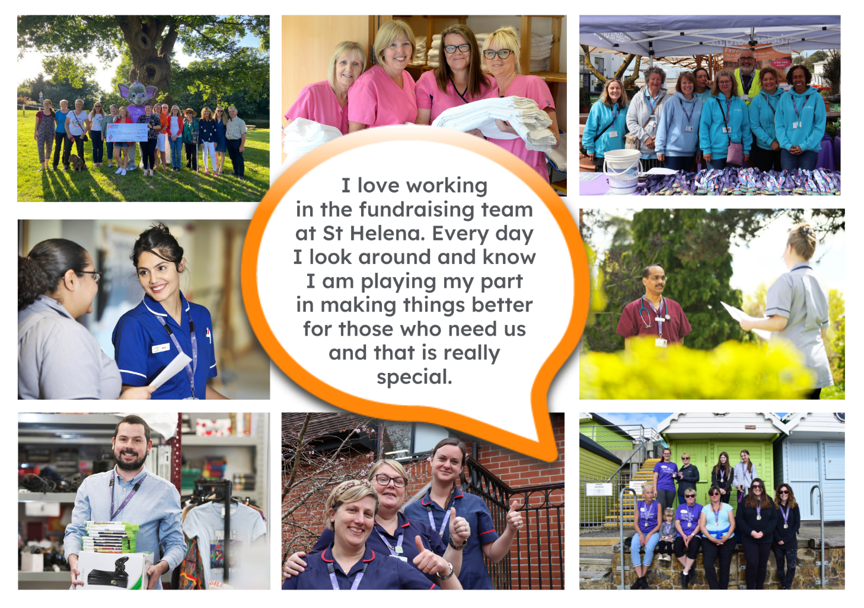
They are feelings….
“It takes an amazingly special place with exceptionally special people to make the hardest times of your life turn into the most precious and so full of love.”

The passion
Whether you work within the clinical team, one of our support services or in the commercial team, each and every team member is incredibly passionate about what they do.
Working for St Helena is a privilege. There’s not many companies you could work for that really make a difference to the local community as St Helena does.
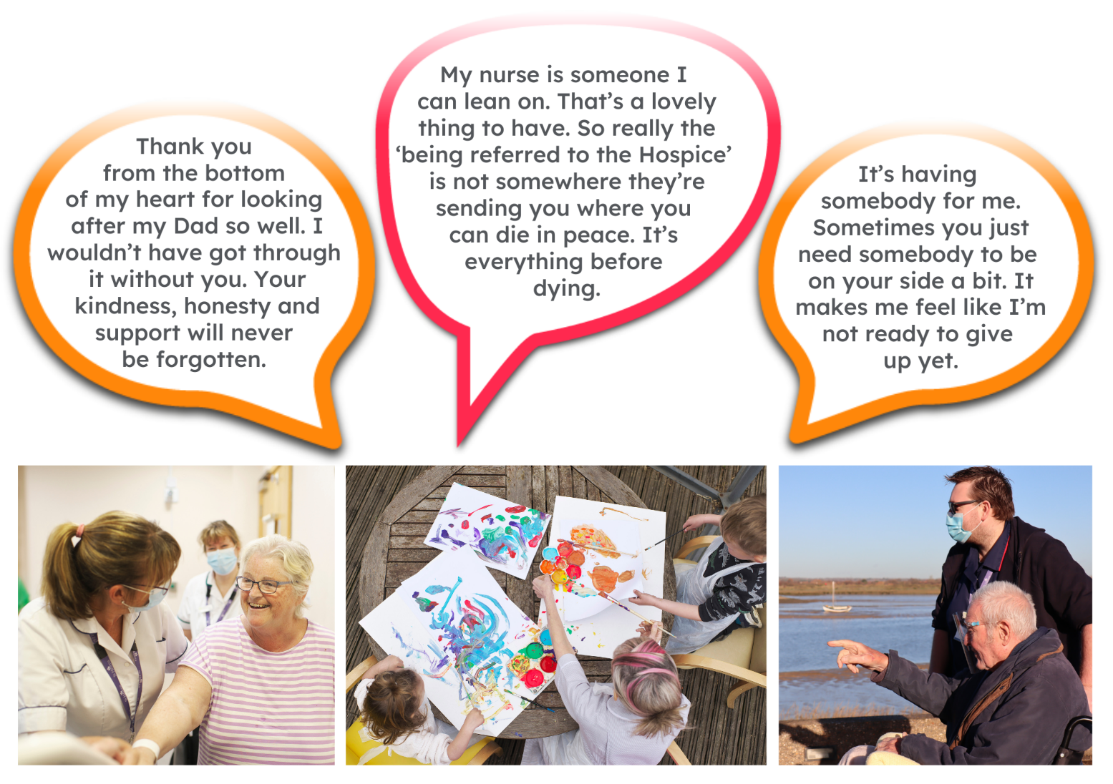
This isn’t just a belief held by those working here; it’s feedback we often receive from the patients and families we support:

Can you really make a difference?

- Last year, we helped 4,171 patients and families facing incurable illness and bereavement. More than we have ever supported before!

- 47,421 calls were made to our SinglePoint 24/7 phoneline.

- £585,058 was raised from local individuals, groups, schools and businesses in the community.

- None of this can be achieved without our amazing team. Everyone plays a part!

The benefits
Not only is working at St Helena rewarding, there are a huge amount of benefits too!
Next steps
We hope we’ve given you a bit of an idea of what an amazing place St Helena is to work and you’re keen to find out more!
Here are the next steps:
- To find out more about St Helena, please visit our website www.sthelena.org.uk

- Apply for the position!

- Please contact us on the details below if you have any questions before or after you apply, we’ll be happy to talk through!

- Follow us on social media @StHelenaHospice to keep in the loop!

We look forward to meeting you!

Contact us:
recruitment@sthelena.org.uk

Registered Charity Number 280919. Registered Office: Myland Hall, Barncroft Close, Highwoods, Colchester, CO4 9JU

