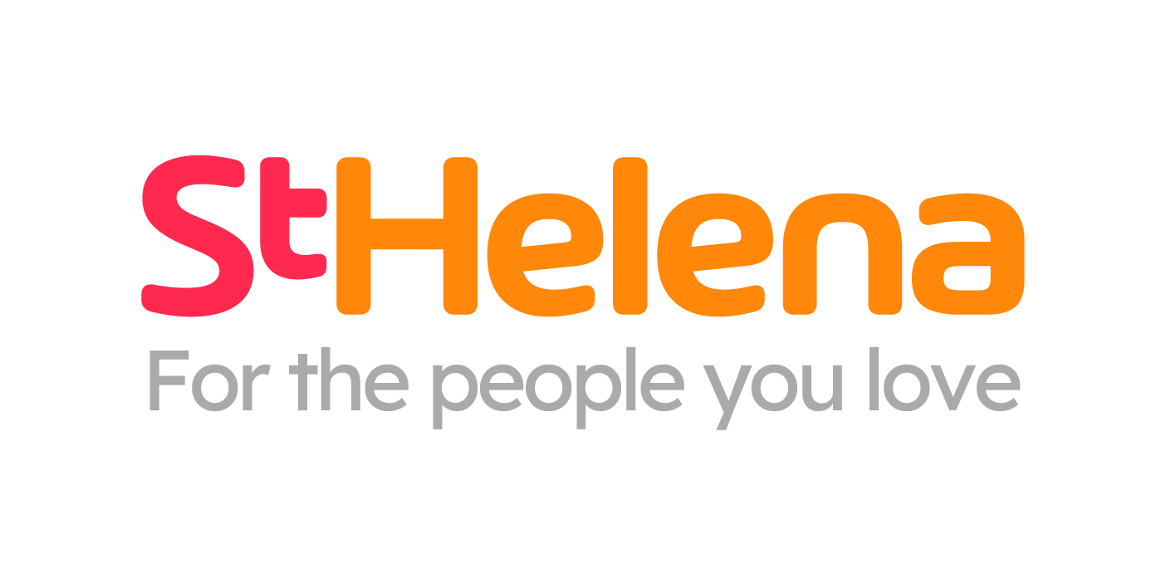

Helping local people face incurable illness and bereavement, supporting them, their families, friends and carers.

Recruitment pack
Donation Centre Driver

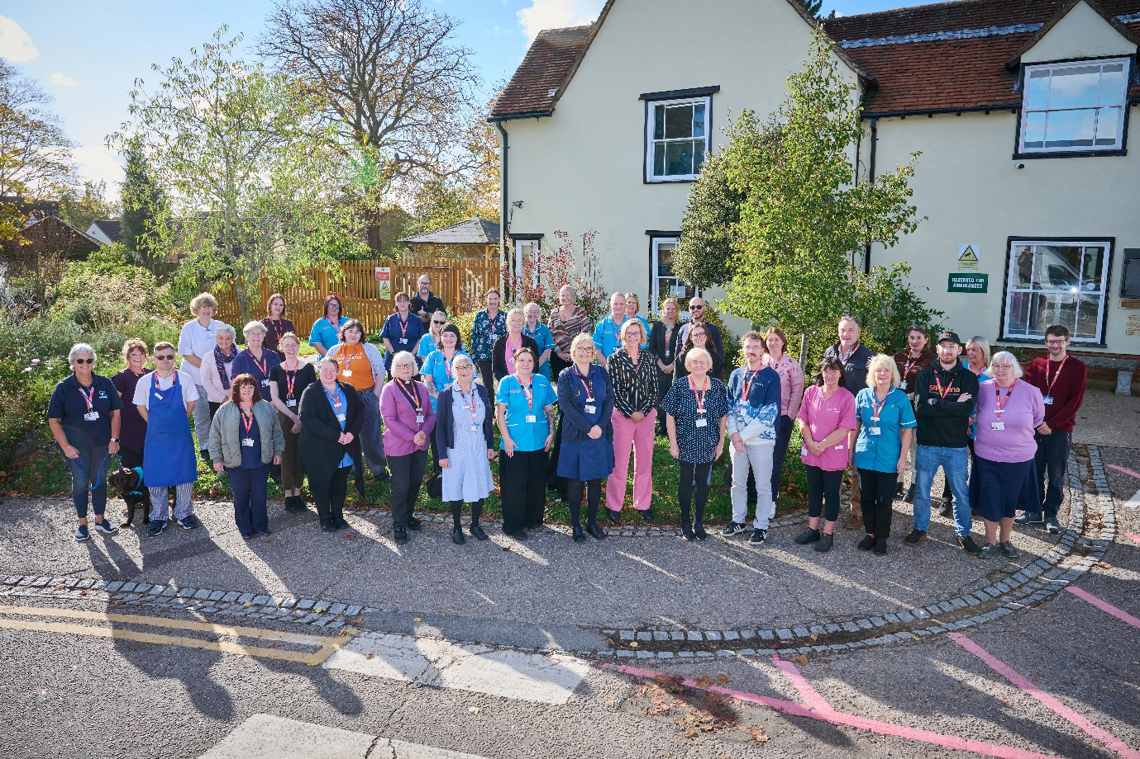
Who is St Helena?

Here at St Helena, we believe that everyone living with an incurable illness has the right to live and die with choice, compassion and dignity. Families deserve to be cared for and anyone coping with loss should be supported through their grief.

Our vision is to create a community where everyone knows that as the end of their story draws near, they will be cared for and die where they choose to be; where loved ones have the opportunity to make the most of life together, surrounded by people who care and support one another.

Since we opened in 1985, this belief drives us to provide the best end of life care and bereavement support to everyone in north east Essex, not just today but for years to come.

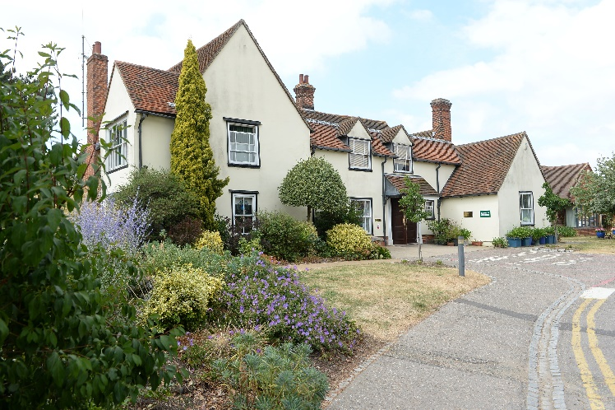
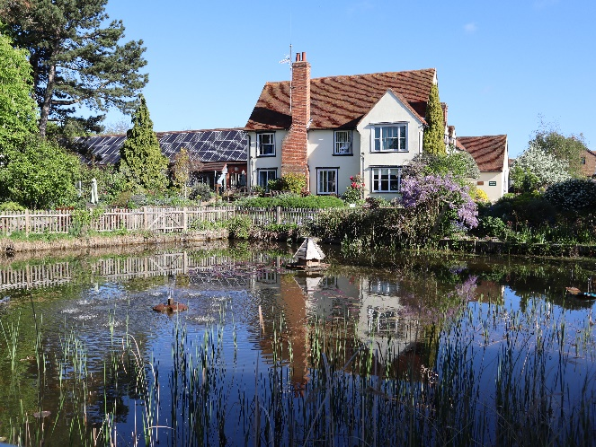
Every year we support more than 4,100 local people facing dying, death and bereavement.
By focusing on their physical, emotional and spiritual needs, we aim to bring comfort and relief to all those who need it, offering the people of north east Essex individual care and total support, regardless of their diagnosis or personal circumstances.
By visiting them in their homes, over the phone with our 24/7 advice line, and at the Hospice in Colchester, through all the smiles and all the tears we guide those who need us, because we believe in making every memory matter.
Not only do we support local people in our community facing incurable illness, but we also support adults and children living in north east Essex through bereavement, regardless of how or where their loved one died.
St Helena is an independent charity, providing our services free of charge. The equivalent of 7 out of 10 of the patients and families we care for and support are funded by people in our local community giving donations, buying from our shops, playing our lottery and leaving gifts in Wills.
We rely on the help and generosity of our fundraisers, donors and volunteers to continue to provide our services. Without them we wouldn’t be here.
What does the role entail?

Place of work | Angora, Peartree Rd
Salary | £24,852.59
Contract type | Permanent 37.5hrs
Reports to | DC Team Leader Out

- Take your career to the next level working with amazing like-minded people
- Work for a company who gives you a platform to do amazing things
- Be in a job where you really make a difference

What are we looking for?
Good organisational and timekeeping skills
Physically fit
Logistical Approach
Full clean driving license

Job Description
JOB OVERVIEW
JOB TITLE | Donation Centre Driver
DEPARTMENT | Retail
LOCATION | Angora Business Park, Colchester
REPORTS TO | Donation Centre Team Lead Out
KEY WORKING RELATIONSHIPS
- Retail, Income and Communications team  - Volunteer workforce  - Customers & general public  - Van drivers |  | - Suppliers / contractors  - Staff within the Hospice  - Other charity retail & fundraising staff
KEY PRIORITIES
- Delivery of stock using company vehicle, delivering to any one of our shops, or Ecommerce dept, following a route schedule as organised by the Donation Centre manager. Collection of unwanted stock from each shop to be returned to the DC.

- At times, to assist in running an efficient and effective Donation Centre operation to maximise profits from the sale of donated goods.
DUTIES & RESPONSIBILITIES
- To deliver goods to our shops on a planned route as specified by the DC manager.

- Making ad-hoc to visits to collect donations from corporate business when donations are offered to St Helena

- To undertake a range of duties as allocated by Donation Centre Manager to ensure an efficient Donation Centre process

- To greet customers donating to St Helena via the Donation Centre demonstrating excellent customer service to represent the organisation in a positive manner and promote any events

- Supervising and supporting volunteers working at the donation point ensuring they all demonstrate excellent customer service. Working in the designated zones (reception, sorting room etc.) and completing all duties as requested

- Ensuring all customers are asked about Gift Aid to maximise the number of new sign ups and repeat customers to the Gift Aid Scheme.

- All Gift Aid donations to be prioritised, sorted and distributed effectively

- To ensure all items once donated are moved efficiently into the current location in the Donation Centre stock system.

- Ensuring all stock areas are kept clear & tidy for ease of product selection and in line with Health & Safety requirements.

- To attend supervisions and meetings with Donation Centre and Logistics Manager and supervisor to ensure good practice, develop new ways of working to give feedback and ensure open lines of communication

- Occasionally to scan items on the computer and research ‘high value items’ which may need special attention e.g. to select alternative avenues of sale such as specialist sales and auctions where the item would achieve a higher profit

- To complete all annual online training to ensure we remain compliant with training needs.

- To help organise and attend to janitorial duties for the Angora site

What is the team like?

Team structure – INSERT ORGANIGRAM

Meet some of the team
Add Director’s photo
Director or Area
Director Bio

Line Manager Title
Line Manager Bio
Add Line Manager’s photo

What is the culture like?

Our values are incredibly important to us. But at St Helena, values are much more than just words…
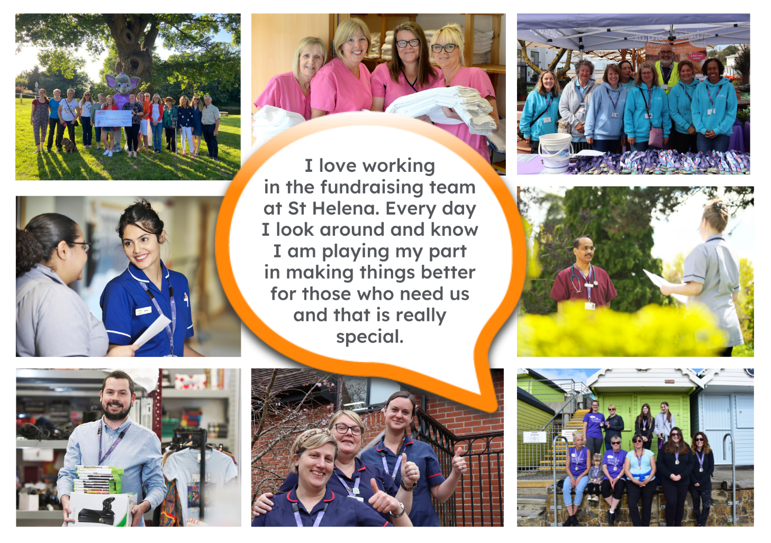
They are feelings….
“It takes an amazingly special place with exceptionally special people to make the hardest times of your life turn into the most precious and so full of love.”

The passion
Whether you work within the clinical team, one of our support services or in the commercial team, each and every team member is incredibly passionate about what they do.
Working for St Helena is a privilege. There’s not many companies you could work for that really make a difference to the local community as St Helena does.
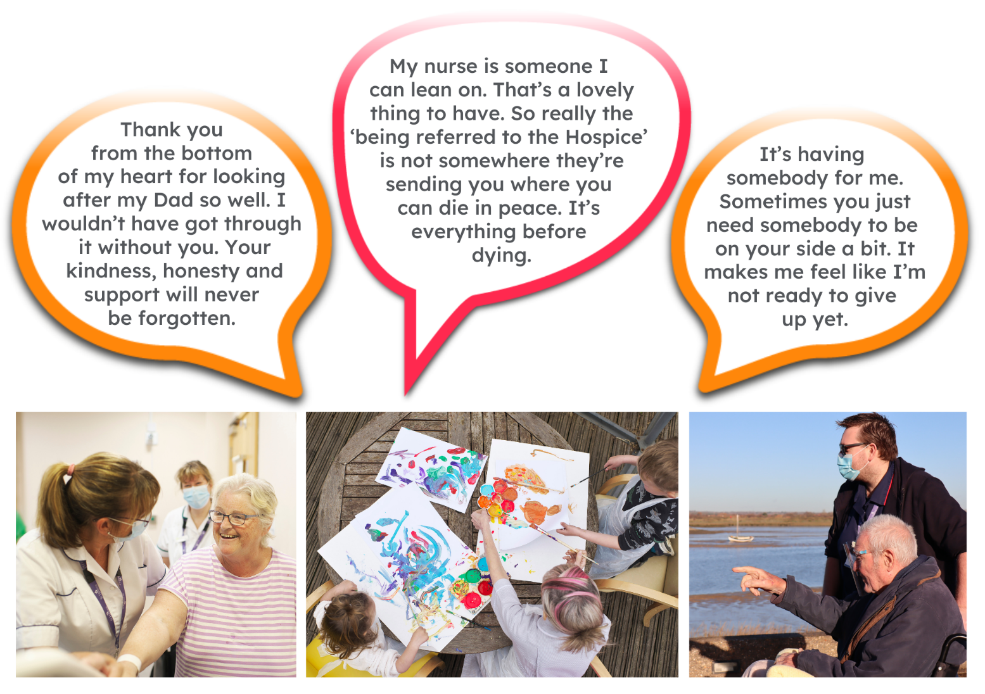
This isn’t just a belief held by those working here; it’s feedback we often receive from the patients and families we support:

Can you really make a difference?

- Last year, we helped 4,171 patients and families facing incurable illness and bereavement. More than we have ever supported before!

- 47,421 calls were made to our SinglePoint 24/7 phoneline.

- £585,058 was raised from local individuals, groups, schools and businesses in the community.

- None of this can be achieved without our amazing team. Everyone plays a part!

The benefits
Not only is working at St Helena rewarding, there are a huge amount of benefits too!

Next steps
We hope we’ve given you a bit of an idea of what an amazing place St Helena is to work and you’re keen to find out more!
Here are the next steps:
- To find out more about St Helena, please visit our website www.sthelena.org.uk

- Apply for the position!

- Please contact us on the details below if you have any questions before or after you apply, we’ll be happy to talk through!

- Follow us on social media @StHelenaHospice to keep in the loop!

We look forward to meeting you!

Contact us:
INSERT CONTACT INFO

Registered Charity Number 280919. Registered Office: Myland Hall, Barncroft Close, Highwoods, Colchester, CO4 9JU

