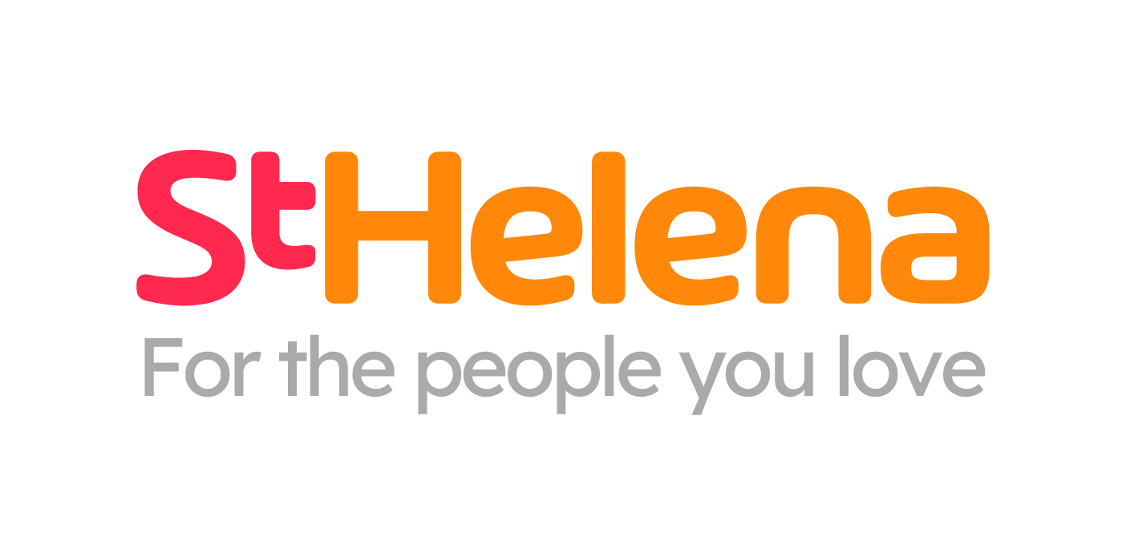

Helping local people face incurable illness and bereavement, supporting them, their families, friends and carers.

Recruitment pack
Community Fundraiser

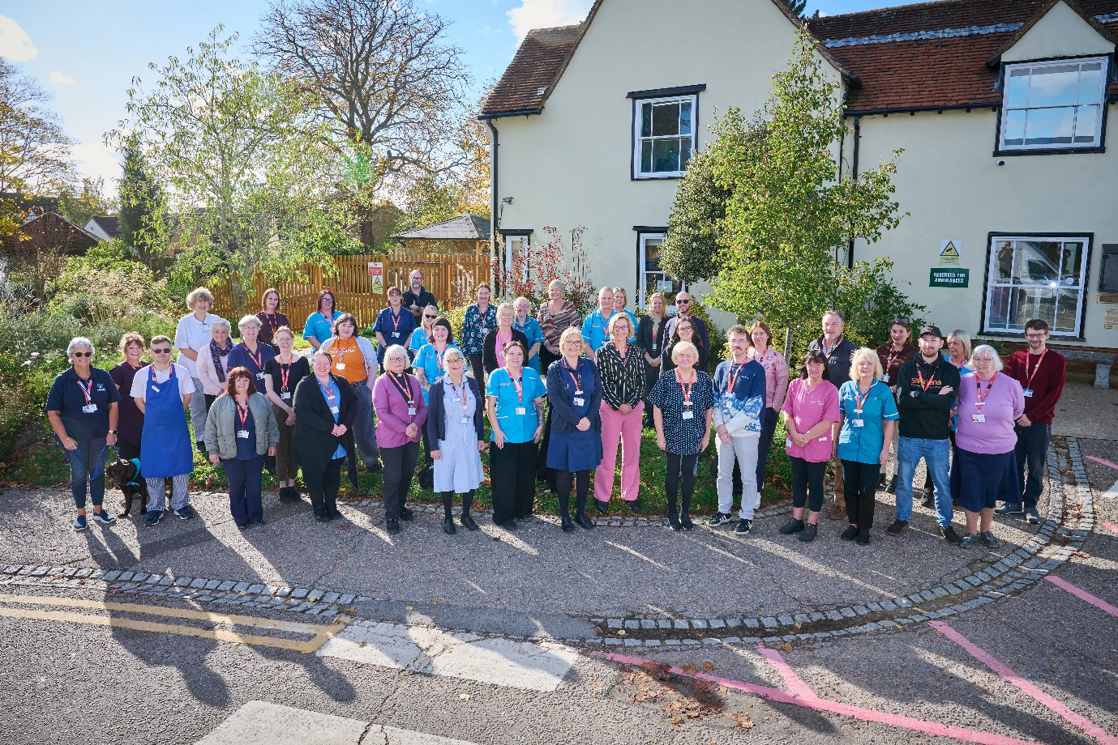
Who is St Helena?

Here at St Helena, we believe that everyone living with an incurable illness has the right to live and die with choice, compassion and dignity. Families deserve to be cared for and anyone coping with loss should be supported through their grief.

Our vision is to create a community where everyone knows that as the end of their story draws near, they will be cared for and die where they choose to be; where loved ones have the opportunity to make the most of life together, surrounded by people who care and support one another.

Since we opened in 1985, this belief drives us to provide the best end of life care and bereavement support to everyone in north east Essex, not just today but for years to come.



Every year we support more than 4,100 local people facing dying, death and bereavement.
By focusing on their physical, emotional and spiritual needs, we aim to bring comfort and relief to all those who need it, offering the people of north east Essex individual care and total support, regardless of their diagnosis or personal circumstances.
By visiting them in their homes, over the phone with our 24/7 advice line, and at the Hospice in Colchester, through all the smiles and all the tears we guide those who need us, because we believe in making every memory matter.
Not only do we support local people in our community facing incurable illness, but we also support adults and children living in north east Essex through bereavement, regardless of how or where their loved one died.
St Helena is an independent charity, providing our services free of charge. The equivalent of 7 out of 10 of the patients and families we care for and support are funded by people in our local community giving donations, buying from our shops, playing our lottery and leaving gifts in Wills.
We rely on the help and generosity of our fundraisers, donors and volunteers to continue to provide our services. Without them we wouldn’t be here.

Place of work | St Helena Hospice, Myland Hall Chase, Barncroft Close, Colchester, CO4 9JU
Salary | 26-28K
Contract type | 37.5 hours per week, permanent
Reports to | Fundraising Manager
Manages | N/A
Budget responsibility | No
Travel | In and around the Colchester area with 2 days working in the office at Myland Hall.

- Take your career to the next level working with amazing like-minded people
- Work for a company who gives you a platform to do amazing things
- Be in a job where you really make a difference

What are we looking for?
- Excellent interpersonal skills
- Well organised and able to manage a busy workload.
- IT literate and comfortable with Microsoft Packages
- Effective communication skills, with good written and verbal presentation skills
- Able to work effectively as a team but also has own initiative.
- Good knowledge of the Colchester Area

JOB DESCRIPTION

JOB OVERVIEW
JOB TITLE | Community Fundraiser
DEPARTMENT | Fundraising
LOCATION | Colchester/hybrid, with flexibility to meet the organisation’s needs.
REPORTS TO | Fundraising Manager

KEY WORKING RELATIONSHIPS
All staff and volunteers at St Helena  Supporters, donors, patients and families | Counterparts in other settings  External agencies and suppliers  Local companies and community groups
KEY PRIORITIES
- To work with the Fundraising Manager to achieve, and where possible exceed the Fundraising Team income target whilst controlling expenditure.
- To raise money for St Helena Hospice by maximising all opportunities to build relationships within our community
- To take a leading role in communications with groups of donors and developing a strong donor journey for those groups.
- To provide excellent donor care offering suitable products and fundraising opportunities ensuring an appropriate donor journey for continued support.
- Proactively build relationships with clinical staff and with patients and families to demonstrate the difference their support will make.
- To develop and implement new fundraising initiatives for different types of supporters
- To work with the Fundraising Manager to develop and implement a portfolio of projects and events.
- Working closely with the data analytics officer to interpret data and strategically and use it to influence the communication plan for the year
- Plan a communication strategy that is looking at relevant asks for specific audiences ensuring supporters are asked in the right way at the right time.
- Build and maintain relationships with individuals, community groups, schools, clubs and local businesses.
- Provide excellent supporter care and stewardship. Thank supporters and demonstrate the impact of their fundraising.
- Identify opportunities to develop and existing relationships and attract new supporters.
- Plan, organise, develop and deliver community fundraising events.
- Recruit, support and coordinate fundraising volunteers.
DUTIES & RESPONSIBILITIES
Planning
- To support the Fundraising Manager – in achieving, and where possible exceeding, the fundraising team’s income through fundraising, whilst controlling expenditure.
- Working with your manager, build and put in place comprehensive plans to meet income targets for fundraising areas assigned to you.
- Research and develop new and different ways to communicate and engage with large groups of supporters to inform the fundraising communication strategy.
- Help prepare and manage communication and marketing plans which are targeted at specific groups to ensure that they are asked in the right way and right time, to achieve the required income targets for certain fundraising areas.
- Following fundraising activities/campaigns undertake appropriate analysis of activity, participation, income etc, against objectives to inform decisions going forward.

Relationship Manage
- To develop new communication strategies to develop relationships with different groups of supporters and nurture any known existing relationships by offering suitable products and opportunities.
- To build strong internal relations throughout the organisation so fundraising is understood and woven within the culture of all St Helena Hospice colleagues,
- To build strong working relationships with the Volunteer Services Team, for all fundraising volunteer requirements.
- To provide a bespoke and personal thanking service to supporters via all forms of communication including telephone when required.

Communication
- To actively promote the ways in which the public can support St Helena Hospice through fundraising activities
- To work with the wider fundraising team to ensure all opportunities are utilised which will result in successful campaigns

Other Responsibilities
- To take the lead on appropriate campaigns and projects, as decided by the Fundraising Manager –ensuring they are well planned and budgets are met.
- To engage with external initiatives e.g. Hospice Care Week, Dying Matters Week
- To carry out any other tasks deemed appropriate by the Fundraising Manager
- To work on other fundraising initiatives as requested by the Fundraising Manager.
- To attend events and engagements where appropriate outside of normal working hours, including weekends and bank holidays.
- To be responsible for own administration and ensure that all relevant donor records are kept up to date on the CRM
- To be conversant with relevant legislation, charity commission guidance, and to have a good knowledge of GDPR advising supporters as appropriate
- To liaise with professional bodies, agencies and other associations as required.

GENERAL - Applicable to all roles at St Helena
All of the above activities are governed by the operational policies, Standing Financial Instructions, policies and procedures and standards of St Helena as well as legislation and professional standards and guidelines.
All employees must comply with St Helena’s Equal Opportunity Policy and must not discriminate on the grounds of sex, colour, race, ethnic, or national origins, marital status, age, disability, sexual orientation or religious belief.
Employees have a responsibility to themselves and others in relation to managing risk, health and safety and will be required to work within the policies and procedures laid down by St Helena. All staff have a responsibility to access occupational health, other staff support services and/or any relevant others in times of need and advice.
All employees have the right to work in an environment which is safe and to be protected from all forms of abuse, violence, harassment and undue stress. All employees are responsible for helping to ensure that individuals do not suffer harassment or bullying in any form. All employees will be personally accountable for their actions and behaviour in cases of complaint of harassment or bullying.
St Helena is a smoke free organisation. Smoking is not allowed in any St Helena premises. If you would like help to give up smoking you should contact your GP or call the NHS Stop Smoking Help Line.
St Helena is a charity and all staff are responsible to ensure that funds are spent in the most sustainable and efficient way. Staff may also be encouraged to join fundraising and other business-related activities to promote the charity’s financial well-being.
PERSONAL DEVELOPMENT
Be aware of own development needs and take appropriate action. Keep updated of evidence based practice and government policies related to care. Act as an effective role model at all times.
PROFESSIONAL DUTIES
To maintain personal professional status, ensuring that the requirements laid down by the relevant professional body for registration are compliant.
Exercise professional accountability as guided by the relevant professional body and maintained in accordance with the policies of the department and St Helena.
ANNUAL APPRAISAL
The post holder will be appraised on an annual basis and the process will include a review of the past year’s performance, setting of aims and objectives for the coming year and identification of educational needs.
TRAINING
All staff will undertake such training as is necessary to perform the duties allocated and any mandatory requirements of St Helena. This will include mandatory training in line with your job role.
QUALITY
St Helena aims towards maintaining the goodwill and confidence of its own staff and of the general public. To assist in achieving the objective it is essential that at all times, employees carry out their duties in a courteous and sympathetic manner.
CONFIDENTIALITY
Your attention is drawn to the confidential nature of information collected and used throughout the NHS. The unauthorised use or disclosure of patient, staff or other personal information is a dismissible offence. The unauthorised disclosure of information could also result in a prosecution for an offence, or action for civil damaged, under GDPR.
SAFEGUARDING CHILDREN AND VUNERABLE ADULTS
All St Helena employees are required to act in such a way that at all times safeguards (and promotes) the health and well-being of children and vulnerable adults. Familiarisation with and adherence to St Helena safeguarding policies is an essential requirement of all employees as is participation in related mandatory/statutory training.
VALUES AND BEHAVIOURS
St Helena’s core values and behaviours will be embedded in our recruitment, training and development review and decision making process.
Bold | In an ever-changing world, we have the confidence and determination needed to innovate, stand out from the crowd and make a real difference every day.
Passionate | We love what we do and we are committed to our cause because it means everything to the people in our community who need our help.
Caring | People will always come first at St Helena. Everyone  is welcome and everyone will be looked after as though they are a part of our extended family.
This job description is not an exhaustive document but is a reflection of the current position. Details and emphasis may change in line with service needs and after consultation with the post holder.

PERSON SPECIFICATION

ATTIRIBUTE | ESSENTIAL | DESIRABLE
Qualifications | - GCSE or equivalent grade C (pass) in English Language and Maths.  - Computer literacy (European Computer Driving License or equivalent experience)  - Further education qualification | - Recognised fundraising qualification  - Educated to Degree level or equivalent level qualification
Experience | - Experience of working in fundraising or a Customer Care or Relationship Management Role or marketing or sales | - Working with CRM Database  - Worked within a Hospice environment.  - Worked within a charity environment
Skills & Knowledge | - Strong organisational and planning skills  - Excellent writing skills  - Analysing of data  - Excellent interpersonal and social skills  - Quality orientation  - Full driving license | - Knowledge of St Helena  - Understanding of Fundraising Law and practice  - Knowledge of CRM software database
Communication | - Excellent verbal and written communication skills  - Tactful, sensitive, tolerant flexible and positive manner  - Negotiation and motivational skills  - Presentation skills  - The Community Fundraising role is such a public facing role that confidence with speaking with the wider community is essential.
Qualities | - Team player  - Commitment to quality and best practice  - Positive, self-motivated and committed to achieving results  - Problem solver  - Good sense of humour  - Professional approach to work  - Assertive  - Ability to multi-task  - Excellent time management skills  - Calm under pressure  - Well organised and efficient  - Adhere to all regulatory procedures

What is the team like?

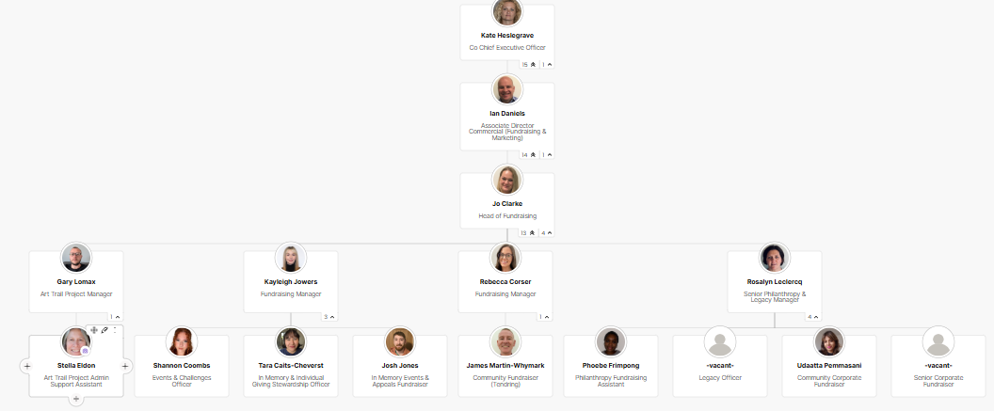

What is the culture like?
Our values are incredibly important to us. But at St Helena, values are much more than just words…


They are feelings….
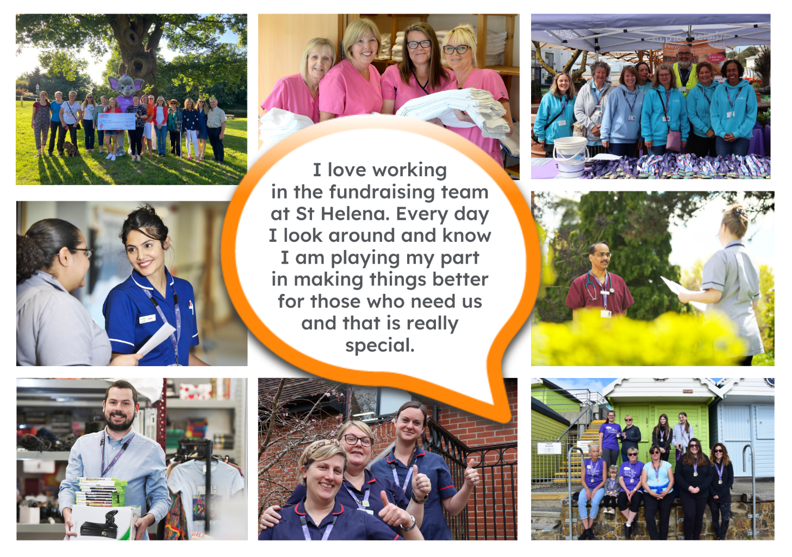
“It takes an amazingly special place with exceptionally special people to make the hardest times of your life turn into the most precious and so full of love.”

The passion
Whether you work within the clinical team, one of our support services or in the commercial team, each and every team member is incredibly passionate about what they do.
Working for St Helena is a privilege. There’s not many companies you could work for that really make a difference to the local community as St Helena does.
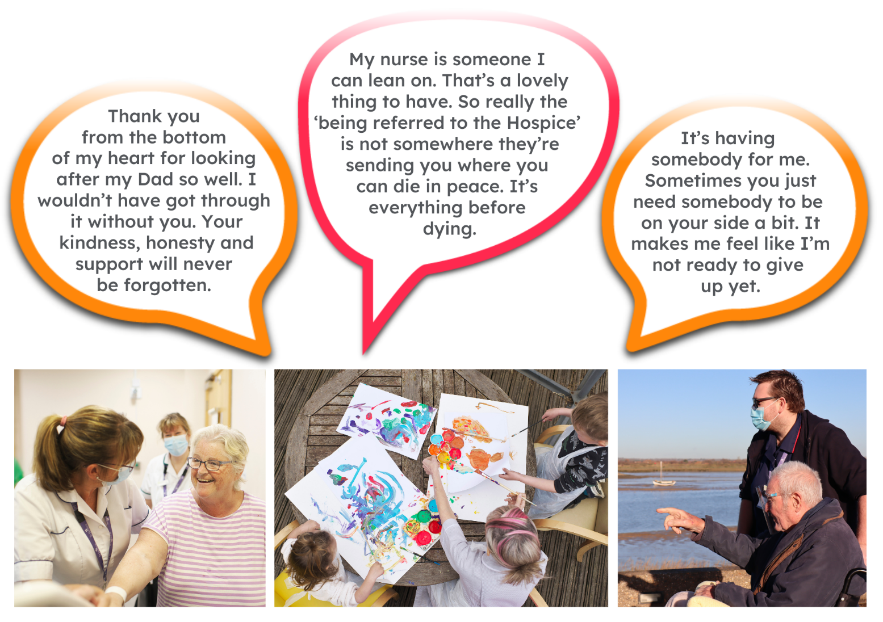
This isn’t just a belief held by those working here; it’s feedback we often receive from the patients and families we support:

Can you really make a difference?

- Last year, we helped 4,171 patients and families facing incurable illness and bereavement. More than we have ever supported before!
- 47,421 calls were made to our SinglePoint 24/7 phoneline.
- £585,058 was raised from local individuals, groups, schools and businesses in the community.
- None of this can be achieved without our amazing team. Everyone plays a part!

The benefits
Not only is working at St Helena rewarding, there are a huge amount of benefits too!

Next steps
We hope we’ve given you a bit of an idea of what an amazing place St Helena is to work and you’re keen to find out more!
Here are the next steps:
- To find out more about St Helena, please visit our website www.sthelena.org.uk

- Apply for the position!

- Please contact us on the details below if you have any questions before or after you apply, we’ll be happy to talk through!

- Follow us on social media @StHelenaHospice to keep in the loop!

We look forward to meeting you!

Contact us:
Rebecca Corser – recruitment@sthelena.org.uk

Registered Charity Number 280919. Registered Office: Myland Hall, Barncroft Close, Highwoods, Colchester, CO4 9JU

