

Helping local people face incurable illness and bereavement, supporting them, their families, friends and carers.

Recruitment pack
Clinical Trainer

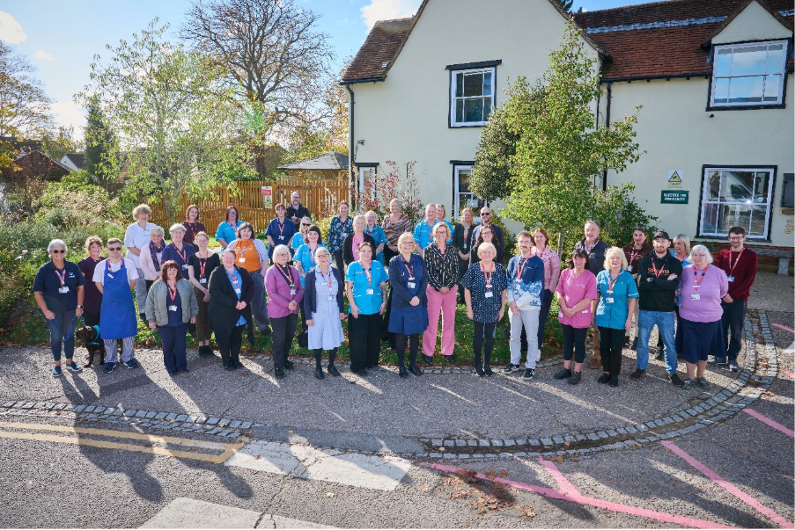
Who is St Helena?

Here at St Helena, we believe that everyone living with an incurable illness has the right to live and die with choice, compassion and dignity. Families deserve to be cared for and anyone coping with loss should be supported through their grief.

Our vision is to create a community where everyone knows that as the end of their story draws near, they will be cared for and die where they choose to be; where loved ones have the opportunity to make the most of life together, surrounded by people who care and support one another.

Since we opened in 1985, this belief drives us to provide the best end of life care and bereavement support to everyone in North East Essex, not just today but for years to come.



Every year we support more than 4,100 local people facing dying, death and bereavement.
By focusing on their physical, emotional and spiritual needs, we aim to bring comfort and relief to all those who need it, offering the people of north east Essex individual care and total support, regardless of their diagnosis or personal circumstances.
By visiting them in their homes, over the phone with our 24/7 advice line, and at the Hospice in Colchester, through all the smiles and all the tears we guide those who need us, because we believe in making every memory matter.
Not only do we support local people in our community facing incurable illness, but we also support adults and children living in North East Essex through bereavement, regardless of how or where their loved one died.
St Helena is an independent charity, providing our services free of charge. The equivalent of 7 out of 10 of the patients and families we care for, and support are funded by people in our local community giving donations, buying from our shops, playing our lottery and leaving gifts in Wills.
We rely on the help and generosity of our fundraisers, donors and volunteers to continue to provide our services. Without them we wouldn’t be here.
What does the role entail?

Place of work | St Helena, Myland Hall, Colchester
Salary | Band 3
Contract type | Part-time 15 hours
Reports to | Head of Hospice Education – Mandy Summons
Travel | Travel to deliver education across Suffolk and Essex

- Take your career to the next level working with amazing like-minded people
- Work for a company who gives you a platform to do amazing things
- Be in a job where you really make a difference

What are we looking for?

An individual that can support and nurture staff working across all three local hospices, work within a care home environment nurturing staff, with a variety of courses to improve practice, knowledge and skills development.
A passion for education and helping others reach their full potential
Build and maintain strong relationships with external stakeholders, including healthcare assistants, care home and care agency staff to promote Hospice Education.
Create and develop new courses in partnership with colleagues in the team
You will be a lifelong learner, ensure your registration is current and practice continuous professional development
JOB DESCRIPTION

JOB OVERVIEW
JOB TITLE | Clinical Trainer
DEPARTMENT | Education
LOCATION | Colchester
REPORTS TO | Head of Education

KEY WORKING RELATIONSHIPS
KEY PRIORITIES
To provide education and training for all three local hospices (40%) and external to the hospice (60%) by:
- Providing training within and beyond the hospice, to other organisations such as care homes, care agencies and hospice staff.
- Plan sessions, share specialist knowledge, develop new topics to meet identified unmet needs in Palliative and end of life care.
- Managed and deliver webinar, face to face and hybrid sessions across Suffolk and Essex
- Supporting and develop education programmes, competencies for hospice staff and responding to urgent or individual training needs if they arise.
- Provide moving and handling sessions for hospice staff
- Supporting staff with growth mindset, reflective practice and professional boundaries

DUTIES & RESPONSIBILITIES
RESPONSIBILITIES
1. To be a source of advice and knowledge on education and training matters around
educational practice, patient care and symptom control.
2. To help identify training needs for those caring for patients and their families. In
particular, working with care homes, care agencies promoting education, to keep and improve the high standards of patient care.
3. To prepare and deliver training in groups, individually or via webinars that meets the need for the hospice and other providers across regionally or nationally.
4. To liaise with other educators and trainers if required to do so.
5. Maintain up to date skills and knowledge in palliative and end of life care and other identified specialist areas

PERSONNEL RESPONSIBILITIES
1. To participate in the induction of all new staff as required.
2. To recognise the value of volunteer contribution and play an active part in their support and development where appropriate.

EDUCATIONAL RESPONSIBILITIES
1. To participate in the Hospice education and training programme.
2. To give feedback from attended education programmes/study days.

PERSONAL DEVELOPMENT
1. To devise with the Head of Education a personal development plan in line with the Hospice objectives and personal needs.
2. To maintain and increase personal professional skills.

ORGANISATIONAL RESPONSIBILITIES
1. To work within the policies of the Hospice
2. To ensure effective use of resources.
3. To respect at all times the confidentiality of information covering patients, staff and volunteers.
4. To play an active part in the development and maintenance of good relationships with all who have business with the Hospice.
5. To promote the Hospice philosophy of care towards patients, relatives and visitors.
Because of the special nature of the Hospice and its work the postholder may on occasion be asked to undertake other duties to help maintain our high standard of care.
THIS JOB DESCRIPTION IS NOT NECESSARILY EXHAUSTIVE AND MAY BE SUBJECT TO REVIEW BY THE HEAD OF EDUCATION IN CONJUNCTION WITH THE POSTHOLDER.

GENERAL - Applicable to all roles at St Helena
All of the above activities are governed by the operational policies, Standing Financial Instructions, policies and procedures and standards of St Helena as well as legislation and professional standards and guidelines.
All employees must comply with St Helena’s Equal Opportunity Policy and must not discriminate on the grounds of sex, colour, race, ethnic, or national origins, marital status, age, disability, sexual orientation or religious belief.
Employees have a responsibility to themselves and others in relation to managing risk, health and safety and will be required to work within the policies and procedures laid down by St Helena. All staff have a responsibility to access occupational health, other staff support services and/or any relevant others in times of need and advice.
All employees have the right to work in an environment which is safe and to be protected from all forms of abuse, violence, harassment and undue stress. All employees are responsible for helping to ensure that individuals do not suffer harassment or bullying in any form. All employees will be personally accountable for their actions and behaviour in cases of complaint of harassment or bullying.
St Helena is a smoke free organisation. Smoking is not allowed in any St Helena premises. If you would like help to give up smoking you should contact your GP or call the NHS Stop Smoking Help Line.
St Helena is a charity and all staff are responsible to ensure that funds are spent in the most sustainable and efficient way. Staff may also be encouraged to join fundraising and other business-related activities to promote the charity’s financial well-being.
PERSONAL DEVELOPMENT
Be aware of own development needs and take appropriate action. Keep updated of evidence based practice and government policies related to care. Act as an effective role model at all times.
PROFESSIONAL DUTIES
To maintain personal professional status, ensuring that the requirements laid down by the relevant professional body for registration are compliant.
Exercise professional accountability as guided by the relevant professional body and maintained in accordance with the policies of the department and St Helena.
ANNUAL APPRAISAL
The post holder will be appraised on an annual basis and the process will include a review of the past year’s performance, setting of aims and objectives for the coming year and identification of educational needs.
TRAINING
All staff will undertake such training as is necessary to perform the duties allocated and any mandatory requirements of St Helena. This will include mandatory training in line with your job role.
QUALITY
St Helena aims towards maintaining the goodwill and confidence of its own staff and of the general public. To assist in achieving the objective it is essential that at all times, employees carry out their duties in a courteous and sympathetic manner.
CONFIDENTIALITY
Your attention is drawn to the confidential nature of information collected and used throughout the NHS. The unauthorised use or disclosure of patient, staff or other personal information is a dismissible offence. The unauthorised disclosure of information could also result in a prosecution for an offence, or action for civil damaged, under GDPR.
SAFEGUARDING CHILDREN AND VUNERABLE ADULTS
All St Helena employees are required to act in such a way that at all times safeguards (and promotes) the health and well-being of children and vulnerable adults. Familiarisation with and adherence to St Helena safeguarding policies is an essential requirement of all employees as is participation in related mandatory/statutory training.
VALUES AND BEHAVIOURS
St Helena’s core values and behaviours will be embedded in our recruitment, training and development review and decision making process.
Bold | In an ever-changing world, we have the confidence and determination needed to innovate, stand out from the crowd and make a real difference every day.
Passionate | We love what we do and we are committed to our cause because it means everything to the people in our community who need our help.
Caring | People will always come first at St Helena. Everyone  is welcome and everyone will be looked after as though they are a part of our extended family.
This job description is not an exhaustive document but is a reflection of the current position. Details and emphasis may change in line with service needs and after consultation with the post holder.

PERSON SPECIFICATION

ATTIRIBUTE | ESSENTIAL | DESIRABLE
Qualifications | - Professional qualification in health and social care NVQ 3 or above  - Evidence of highly developed EoL and palliative care knowledge underpinned by theory and experience  - Knowledge and understanding of palliative care services and recent initiatives in health and social care  - High standard of IT literacy (e.g. word processing, e-mail, PowerPoint) | - Additional IT literacy skills (including database work)  - Knowledge of educational and practice development related initiatives in the statutory and voluntary sectors  - Dementia or Alzheimer train the trainer qualification  - Professional qualification in teaching e.g. AET, CET or DET.
Experience | - Evidence of working within a care home environment  - Evidence of effective training, teaching, facilitation and presentation skills | - Experience of working in a palliative care service  - Experience of working as a HCA trainer  - Evidence of participation in Continual professional practice
Skills & Knowledge | - Ability to work effectively with people with diverse skills, abilities and experience  - Excellent verbal, written and numeracy skills, able to convey ideas or concepts in a way that is easily understood  - Ability to devise and deliver training programmes, including delivering training to large groups  - Ability to plan and organise activities regarding practice education programmes  - Ability to reflect on practice and propose changes  - A flexible attitude and approach to the changing work environment and to provide the flexibility of service required by the families seeking St Elizabeth’s services.  - Ability to manage own time  - Ability to prioritise work  - Ability to work to deadlines  - An understanding of what motivates staff  - Self-motivated, pro-active, energetic and creative  - Proven track record of reliability  - Comfortable working autonomously, with minimal supervision  - Able and willing to work within an EoL and palliative care environment.
Other requirements | - Must have full driver’s licence and own transport.  - Evidence of commitment to own continuing professional development  - Ability to travel across the region on a regular basis and complete shadow shifts in care homes
Organisational Chart
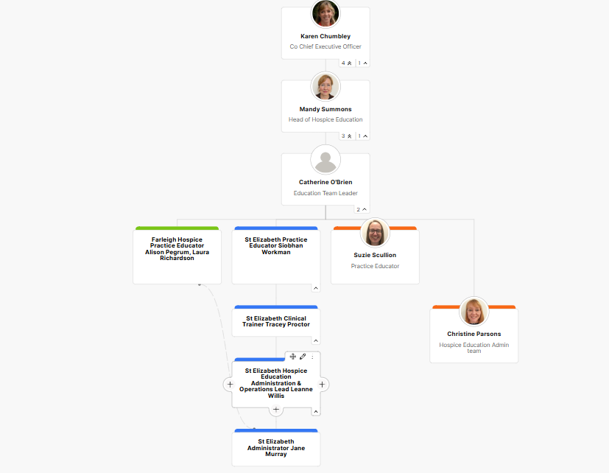

Meet some of the team
Hi, I am Mandy Summons Head of Hospice Education.
I have worked in a hospice setting for the last 13 years and feel privileged to by part of this team. I am passionate about enabling people to reach their full potential and have a like-minded team. Working across all three local hospices (St Elizabeth, St Helena and Farleigh hospice) has been my ambition since joining the palliative and end of life charity sector. Come and join us to make a difference and see the impact education can have on individual colleagues’ careers, knowledge development and skills.


What is the culture like?
Our values are incredibly important to us. But at St Helena, values are much more than just words…

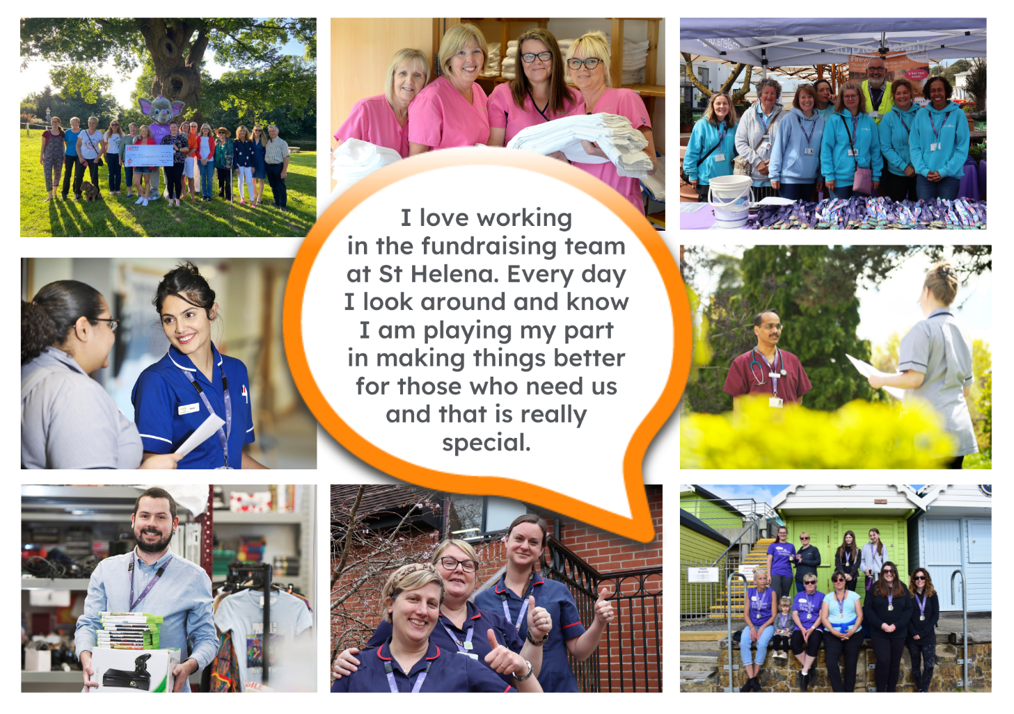

They are feelings….
It takes an amazingly special place with exceptionally special people to make the hardest times of your life turn into the most precious and so full of love.”
The passion
Whether you work within the clinical team, one of our support services or in the commercial team, each and every team member is incredibly passionate about what they do.
Working for St Helena is a privilege. There’s not many companies you could work for that really make a difference to the local community as St Helena does.
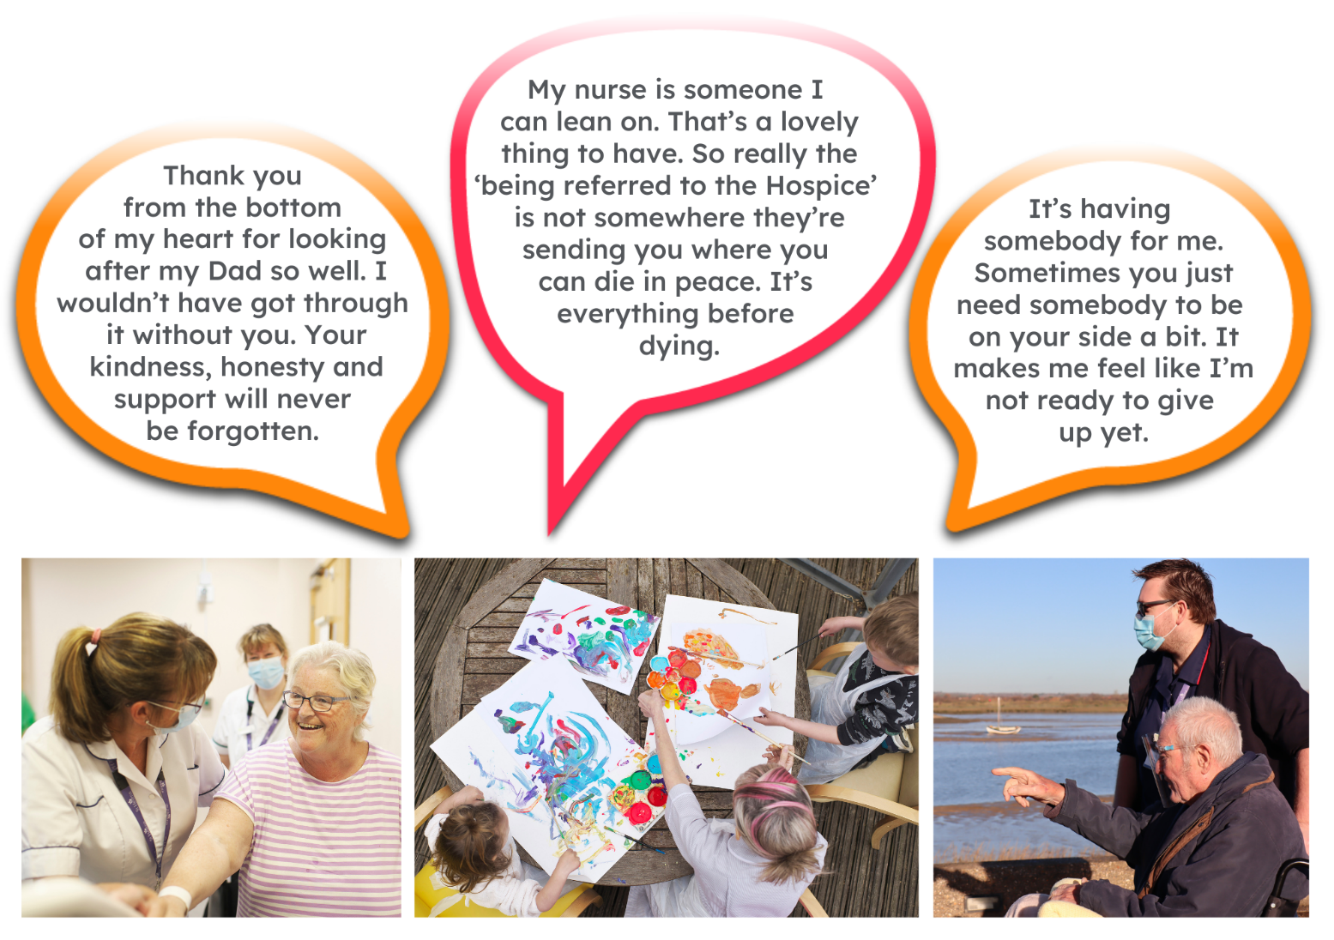
This isn’t just a belief held by those working here; it’s feedback we often receive from the patients and families we support:
Can you really make a difference?
- Last year, we helped 4,171 patients and families facing incurable illness and bereavement. More than we have ever supported before!
- 47,421 calls were made to our SinglePoint 24/7 phoneline.
- £585,058 was raised from local individuals, groups, schools and businesses in the community.
- None of this can be achieved without our amazing team. Everyone plays a part!
The benefits
Not only is working at St Helena rewarding, there are a huge amount of benefits too!
Next steps
We hope we’ve given you a bit of an idea of what an amazing place St Helena is to work and you’re keen to find out more!
Here are the next steps:
- To find out more about St Helena, please visit our website www.sthelena.org.uk

- Apply for the position!

- Please contact us on the details below if you have any questions before or after you apply, we’ll be happy to talk through!

- Follow us on social media @StHelenaHospice to keep in the loop!

We look forward to meeting you!

Contact us:
For more information about the role please contact us recruitment@sthelena.org.uk

Registered Charity Number 280919. Registered Office: Myland Hall, Barncroft Close, Highwoods, Colchester, CO4 9JU

